A000-Am,C-Taino-Tripointer-Image of YaYa on Neck-Silicified Sandstone-1000 CE

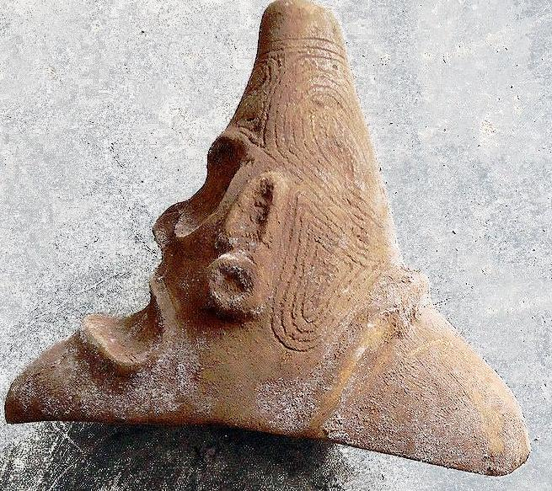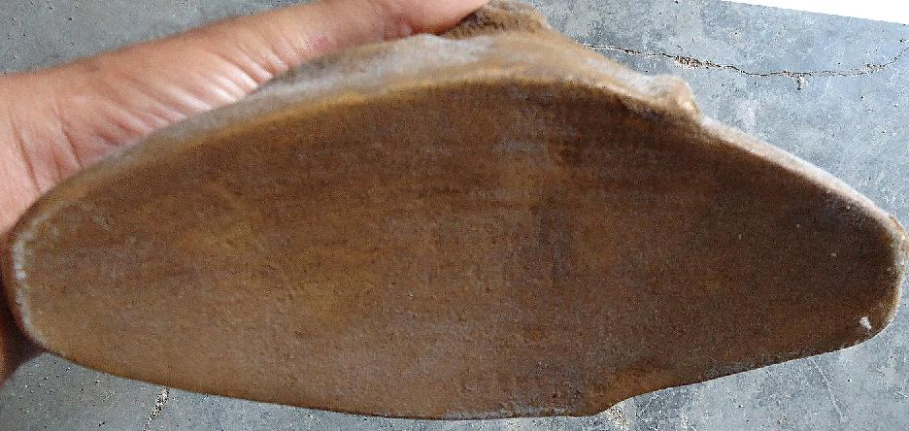

Three-pointed stone: Silicified sandstone.

**Case No.: 17**

**Accession No.**

**Formal Label:** Am,C-Taino-Tripointer-Image of YaYa on Neck-Silicified Sandstone-1000 CE

**Display Description:**

The apex of three-pointed stones has been thought to be the conucos or mound from which the yucca plant sprouts. Hence, its geometrical shape is a metaphor for fructification, and this is why so many otherwise blank spaces are filled with these triangular shapes so that the object so decorated will invoke fruitfulness.

**LC Classification:**

**Date or Time Horizon:**

**Geographical Area:**

**Map:**

**GPS coordinates:**

**Cultural Affiliation:**

**Media:**

**Dimensions:**

**Weight:**

**Condition:**

**Provenance:**

**Discussion:**

**References:**

Bidó, Rafael Garcia. 2014. *Voces de Bohio vocabulario la cultura Taína*. 2nd ed. Santo Domingo: the author.

# Colón, Fernando. [1959] *The life of the admiral Christopher Columbus*. Translated from *Historie del S.D. Fernando Colombo; nelle qualis'ha paritcolare, & vera relatione della vita, & de' fatti dell'Ammiraglio D. Cristoforo Colombo, suo padre*, annotated, and with a new introduction by Benjamin Keen. New Brunswick, N.J.: Rutgers University Press, [1959]

Zayas y Alfonso, Alfredo. 1914. *Lexicografia antillana. Diccionario de voces usadas por los aborigines de las antillas mayors y algunas de las menorees y considerations acerca de su significado y de su formación.* Havana: El Siglo XX de Aurelio Miranda.